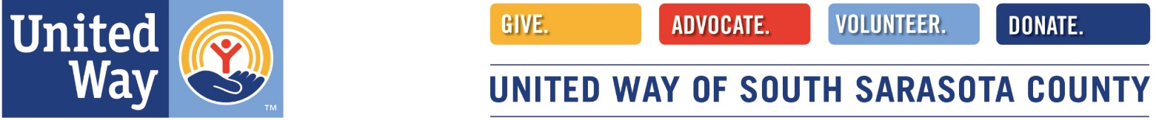
Volunteer Information Form
Name: ____________________________________________ Date: _______________
Address: _______________________________________________________________
City: _________________Zip: ____________
Home Phone: (____) ________________ Cell Phone:(___) ___________________
Other: (____) _______________ Email Address: ____________________________________________
Birth Month & Day: ____________________________________________
Do you live here year-round? Yes No
If No, from month to month____________________________________________
Do you have any medical conditions, limitations, allergies or fears?
Emergency Contact Name: ____________________________________________
Phone Number: ____________________________________________
How did you hear about United Way South Sarasota County? ____________________________________________
Why are you interested in becoming a volunteer? ____________________________________________
Is this for school-required community service? Yes_______ No _________ If yes list the school: ___________________________________________
As a volunteer for United Way South Sarasota County, I agree to abide by the policies and procedures. I understand I will be volunteering at my own risk. UWSSC, its employees or affiliates, do not assume any responsibility or liability for any accident, injury, or health problems which may arise from any volunteer work I perform. As an UWSSC volunteer, I agree that all work I perform is on a voluntary basis and I am not eligible to receive any monetary payment or rewards. I agree that I am not volunteering as part of any court-appointed or teen court-appointed community service program. I fully understand and agree with the terms of this agreement.
I agree to abide by the code of ethics outlined in this packet.
Signature: ________________________________________Date: ________________________
(Parent or Guardian signature if under 18 years of age) ________________________________________
*Our Programs & Volunteer coordinator is happy to walk you through the remaining pages, please just fill out at a minimum this first page and return to us! programs@uwssc.com or questions: 941.484.4811 x 103
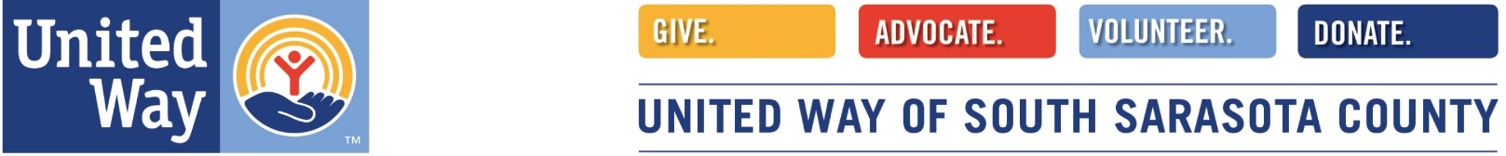
AREAS OF INTEREST, SKILLS and BACKGROUND
I am a: __ Seasonal Floridian (List months of the year in FL) _____________________________
__ Full time Florida Resident

List other organizations you volunteer for and in what capacity:
_________________________________________________________________________________________________________________________________________________________________________________________________________________________________________________________________________________________________________________________________________________________________________________________________________________

Technology Comfort level (what is your comfort with technology on a scale of 1-10, 10 being the most confident)
___ Word Documents ___ Excel ___Using internet and online forms __ Database

List other skills and special qualifications (bookkeeping, accounting, communications, retired professional such as lawyer, teacher, etc.)
__________________________________________________________________________________________________________________________________________________________________________________________________________________________________________________________________________________________________________________________________________________________________________________________________________________
Please check the volunteer areas that interest you.
__Advocacy __ Mentorship __Women’s Empowerment __ Fundraising __ Outreach
__ Event Planning __Event Logistics (set up/ break down) __ Grant Writing
__ Speaking Bureau
__ VITA (Volunteer Income Tax Assistance) Program (see attached description)
__Volunteer Reviewer of Grant Applications for out Allocations Committee (see attached description)
Other: ____________________________________________________________

Circle the day(s) and shift(s) available:
Monday: AM and/ or PM
Tuesday: AM and/ or PM
Wednesday: AM and/ or PM
Thursday: AM and/ or PM
Friday AM: and/ or PM
Saturday: AM and/ or PM
Sunday: AM and/ or PM

__ VITA (Volunteer Tax Assistance). Program Volunteer Opportunities.
The IRS's Volunteer Income Tax Assistance (VITA) and Tax Counseling for the Elderly (TCE) programs offer free basic tax return preparation to qualified individuals.
The VITA program has operated for over 50 years, offering free tax help to:
- People who generally make $57,000 or less
- Persons with disabilities; and
- Limited English-speaking taxpayer who needs assistance in preparing their own tax returns.
In addition to VITA, the TCE program offers free tax help, particularly for those who are 60 years of age and older, specializing in questions about pensions and retirement-related issues unique to seniors.
___ Center greeter ___ Site coordinator ___ Tax preparation ___ Quality Reviewer
DESCRIPTION of these roles:
Greeter Screener: The Greeter/ Screener provides support to the VITA Site Coordinator and volunteer tax preparers by ensuring each taxpayer has the necessary information required to complete his/her return.
Site Coordinator: The Site Coordinator coordinates the tax site making sure that the site runs smoothly. He or she solves any problems as professionally as possible keeping in mind that the clients are the top priority.
Tax Preparer: The Tax prepare provides high-quality tax return preparation to taxpayers who qualify for VITA assistance. Enter tax information into the TaxSlayer software. Obtain signatures for E-File authorization. Answer questions and/or use available resources to assist taxpayers
Quality Reviewer: The Quality Reviewers review each tax return completed by a volunteer, correct errors, and provide substantive tax knowledge and guidance to volunteers. The Quality Reviewer also assists the Site Coordinator in ensuring the efficient operation of the tax site
___ Allocations Reviewer:
Community Impact/ Allocations committee
Our Board of Directors and staff considers this process to be one of our most important community functions and values, because it demonstrates our community commitment to safeguarding our investments of your wonderful donations.
Every year we thoroughly "vet" each agency who applies for program funding for that programs' financial stability and community impact. Our funds are raised within South County and thus stay in South County for the most pressing recognized needs. That is why it is our policy to involve those who live here in South Sarasota County as advocates, donors and volunteers.

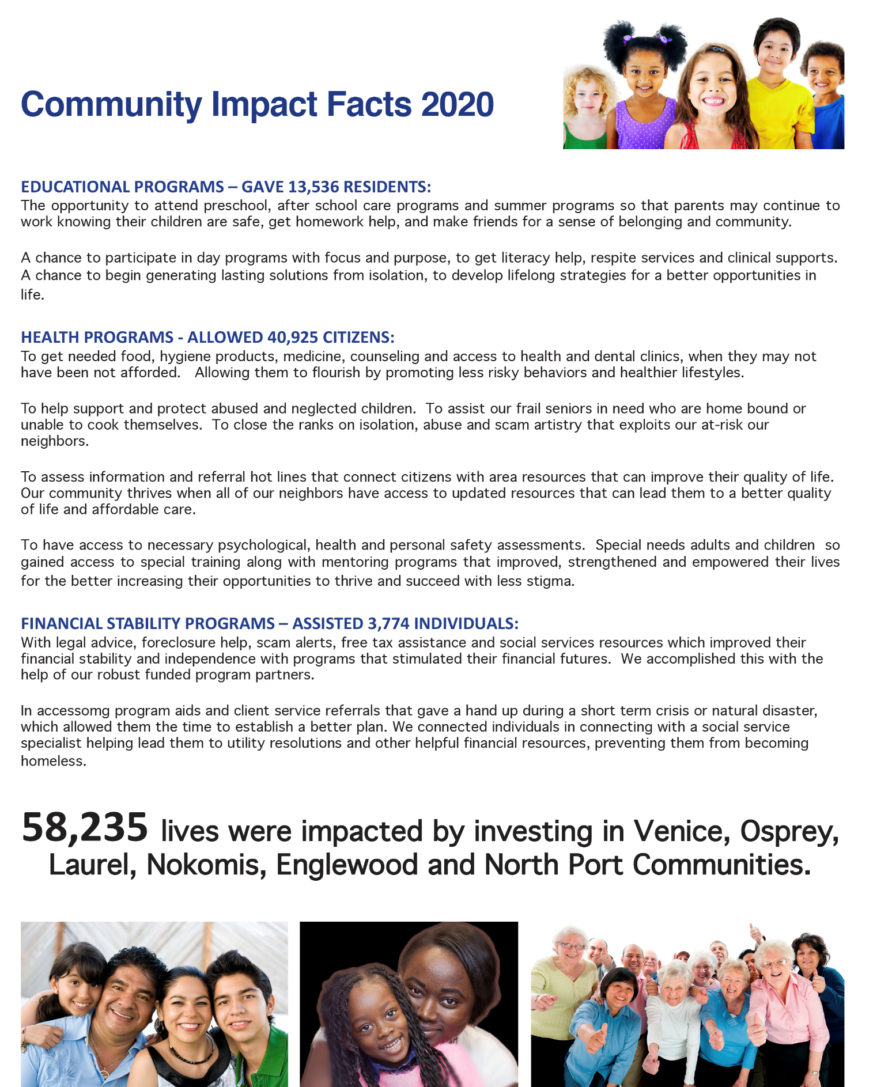

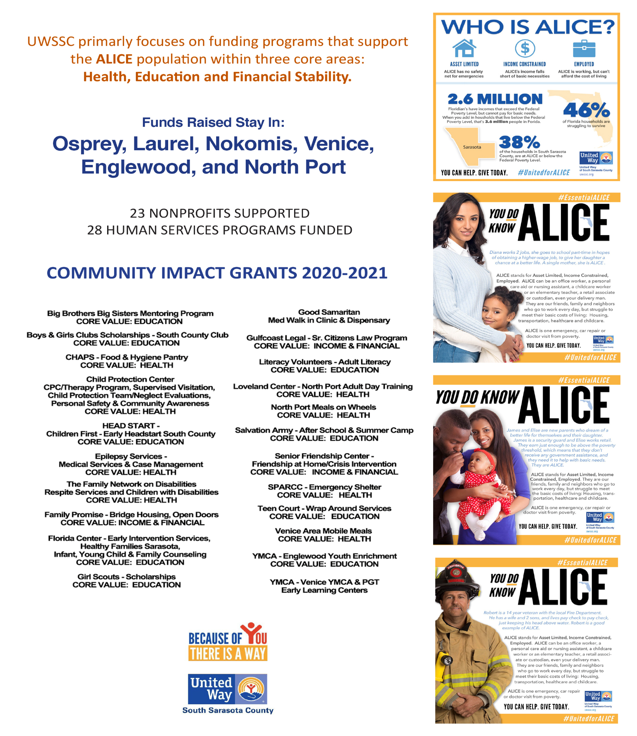

Volunteer Conflict of Interest Policy

The Standard of behavior the United Way of South Sarasota County (UWSSC) is that all staff, volunteers, and board members scrupulously avoid conflicts of interest between the interests of the UWSSC on one hand, and personal, professional, and business interest on the other. This Includes avoiding potential and actual conflicts of interest, as well as perceptions of conflicts of interest.

I understand that the purposes of this policy are to protect the integrity of UWSSC’s decision- making process, to enable our constituencies to have confidence in our integrity, and tom protect the integrity and reputations of volunteers, staff, a and board members. Upon or before engaging as a volunteer for UWSSC I will make a full, written disclosure of interests, relationships, and holdings that could potentially result in a conflict of interest. This written disclosure will be kept on file and I will update it as appropriate.
In the course of meetings or activities, I will disclose any interests in a transaction or decision where I (including my business or other nonprofit affiliations), family, and/or my significant other, employer, or close associates will receive a benefit or gain. After disclosure, I understand that I may not be allowed to continue my participation in certain meetings or activities where a conflict of interest may exist.
I understand that this policy is meant to supplement good judgement, and I will respect its spirit as well as its wording.

Volunteer Printed Name: _______________________________________
Volunteer Signature: ___________________________________________

UWSSC Volunteer Member Agreement & Statement of Expectations
Mission
United Way of South Sarasota County improves lives by mobilizing the caring power of the collective communities of: Venice, Englewood, North Port, Laurel, Nokomis, and Osprey to fund local programs that help fight for healthcare, education, and financial stability for members of our community.
Vision
A community united where all residents have equal opportunities for success.
Values
Values are the fundamental beliefs that help guide our organization.
Integrity
With transparency our actions will always support our mission.
Stewardship
The careful and responsible management of donor funds, volunteer time, and resources.
Diversity, Equity & Inclusion
Making diversity, equity, and inclusion central to our mission, increases philanthropy and has greater impact.
Innovation
Continual development of creative strategies that will adapt to the changing needs of our community.
Collaborations
Applying trust, respect, willingness, empowerment, and effective communication in building relationships with our community partner and business community to make a greater impact.
As a United Way South Sarasota County volunteer, I agree to uphold the mission, vision, and
United Way of South Sarasota County Mission, Vision and Values. I agree to comply fully with the standards, policies, and procedures contained in this manual.
I agree to:
- Become familiar with the above mission, vision, and values of our organization.
- Commit time, thought and effort to UWSSC.
- If inspired, make an annual financial contribution according to personal means.
- Participate in UWSSC fundraising activities in a variety of ways.
- Inspire friends/associates who might be prospective donors, board members, or committee members.
- Represent UWSSC to the community.
- If inspired, invite UWSSC staff to speak at group meetings you attend - religious, professional associations, and/or services groups.
- Avoid conflict of interest. (See conflict of interest packet.
NAME: _________________________________ SIGNATURE: _____________________________DATE:______

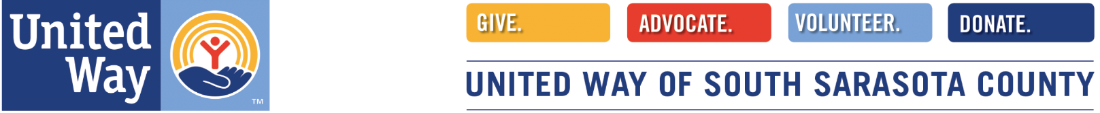
Dear New South Sarasota County Volunteer,
I am so pleased and proud to have you come on board with us in this exciting year of expansion!
We mobilize the caring power of the community by leading with a growth mindset, modeling diversity, equity, and inclusion, understanding the communities we serve and engaging that community with relevant issues.
We endeavor each day to deliver awesome experiences and to engage and strengthen channels year-round. We offer the best-in-class fundraising, digital experience and volunteer opportunities, and are excited to leverage our people process and technology to accomplish our mission!
We look forward to you getting to know our staff team talent and family of volunteers and look forward to you enjoying using your existing talents and skills sets to help us assist those in greatest need in our community!

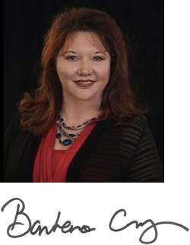
Barbara Cruz, President & CEO
United Way South Sarasota County
157 Havana Road, Venice, FL 34292
Office: 941-484-4811, Cell: 941-525-4061
Barbara@uwssc.com www.uwssc.org

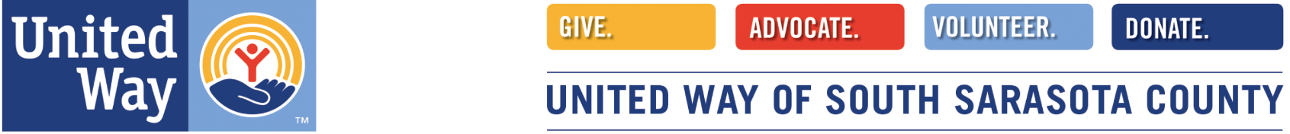

Dear Volunteer,
I am Gallagher, the official United Way mascot, who helps bring attention and excitement to our United Way campaigns and events!
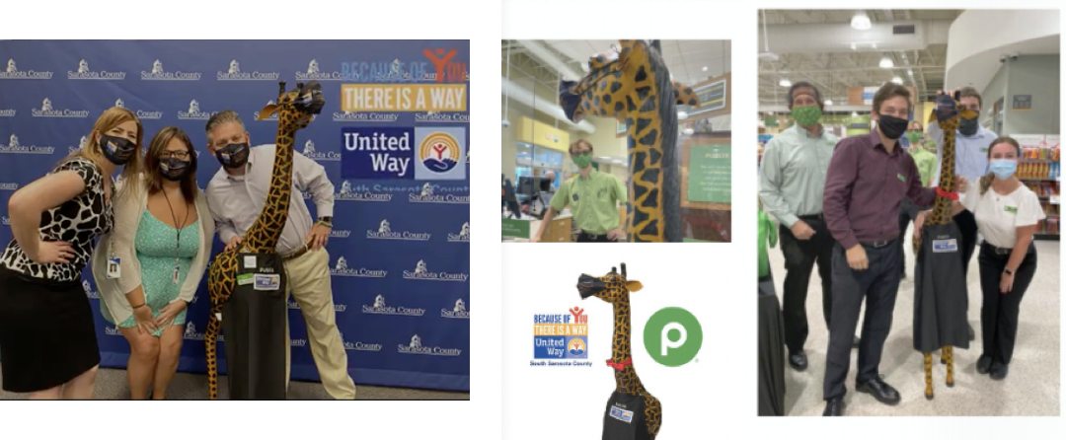
I am named after our United Way Worldwide President & CEO, Brian Gallagher.
I endeavor to get a photo at some point with all our new volunteers, and my booking & publicity agent, Erin Lilly, Public Relations & Resource Development Director here at United Way needs to know when you will be at our event or at your volunteer location. Please touch base with her and introduce yourself, so she may schedule a photo of you with me.
Erin Lilly - 941.525.4128 cell/text development@uwssc.com
In the service of our community,
Gallagher
United Way South Sarasota County Official Mascot

